Beki Hale
GEOG-1700
December 9th, 2015

Global Climate Change

As we went over in assignment 12.2, Global Climate change is affecting us all around the world. It is has been proven that there is concern for the problem of Global Warming in some places, and it has been proven that in other places there isn’t. What makes this something that people wouldn’t want to look at as something they need to help make the world a better place? The only explanation I can come up with is lack of information or the overwhelming feeling you get when you hear that one person alone won’t make a single thing change, but millions of people will. How can you feel like you are going to make the world a better place if you don’t see others doing it? It is so overwhelming to think that there IS something we can do to preserve what we have left of our earth but only with everybody working at it. All of the people in North & South America, Africa, Asia, Antarctica, Europe, Australia working together to preserve the world. That’s just about as big of an ask as you can get from humans. Especially those who don’t even believe what your are saying is fact is actuality.
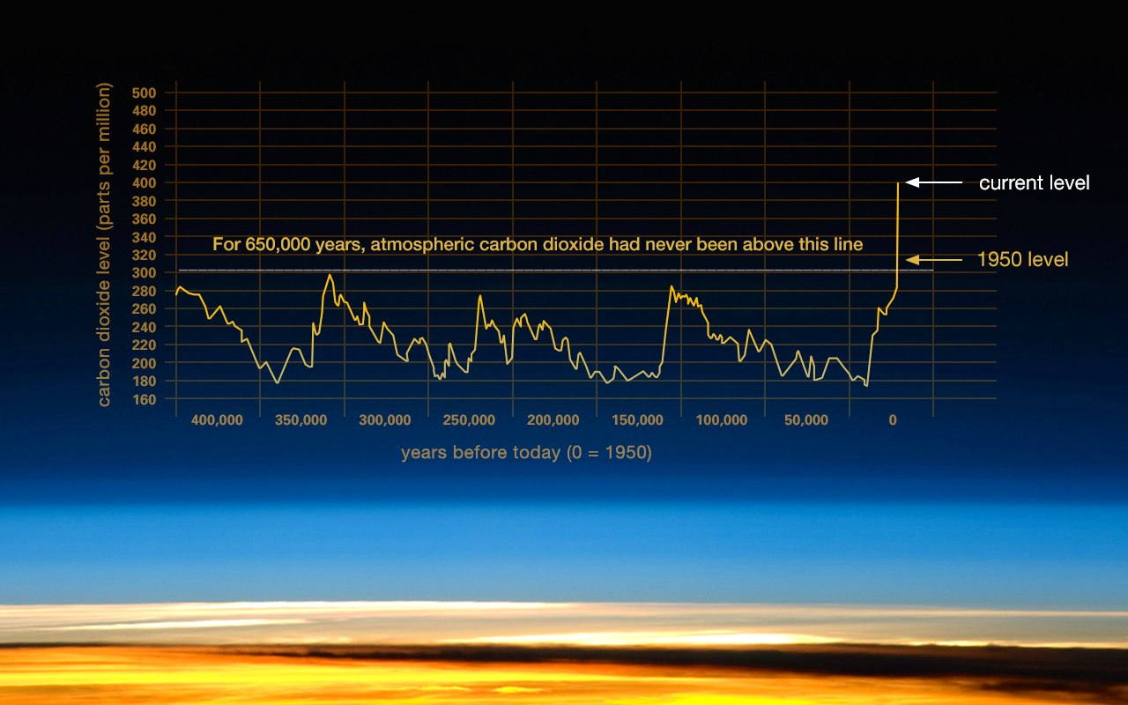
When starting this assignment I thought, “I’m totally for a change in the better for climate control”. After watching all of the clips in the assignment, I found that I am even more on the side of change is needed so we can preserve our earth’s climate. I can’t compete with a scientist perspective because they have the facts that were found with research and hard work. Although so many of the facts come with mountains of data to back it up, it is surprising that the majority of Americans disagree with the experts. I don’t feel like scientific fact should be based on polls, why wouldn't they be fact? The root cause of global climate change is the earth itself is deteriorating, and humans are only rushing the natural process. With all of the pollution and chemicals we are creating and putting into our air we are making our world a place where in a few short decades we (or our children and their children) will see the drastic changes that we have made to our earth.
(Credit: Vostok ice core data/J.R. Petit et al.; NOAA Mauna Loa CO2 record.)
To take one side or the other is with anything in life. In the first video: Climate Change 2013: The physical Science Basis is a little shocking. It is interesting how we measure our climate and the estimation of what is to come. It is surprising that it’s not just about human influence that we will have temperatures rise creating climate change. That it is both the earth’s nature change AND the human footprint that will create this change. The projections they show make me pause and in awe because they are so vastly different. In the Gavin Schmidt: The emergent patters of climate change clip made me feel a little overwhelmed by how much there is to know about the earth. The fact that they are still coming up with questions to add to the pieces of the already questions standing seemed a little tedious, and I feel like some might see success with solving these questions, but I also feel that some of these people may not see the success in their lifetime. Not only that but it will probably never be appreciated by the average everyday person. Again, I appreciated the scope of what the future of our planet looks like, however the hope of reaching the optimal result of hardly any change seems to be out of reach.
In the Climate change 2014 video it was good to hear that there are other countries keeping track of the climate as well, and it’s not just in our country. I never assumed that it was just our country but it is easy to think simply and where we know. To have developing countries and developed countries have risk to climate change can be as simple as thinking that they’ve got great scientists to oh man, what are those people going to do? It is something that I never put a huge thought into.
Reflection:
To have to adapt to something that we haven’t been accustom to is a tough thing to accomplish. As this clip goes though the steps though different areas on the globe it is totally possible. Which option will the MASS people want to pursue? I know I am on board to do my part to make the world a better place for my not only my kids, but all of our future generations who get to live on this earth.
Global climate change is already affects us around the globe, and will continue to get worse through the decades. I have learned so much from this whole course and this assignment really makes me value and look ahead to what the future will be for my kids and their kids and so on. I found a quote on the National Geographic website that says “Scientific evidence for warming of the climate system is unequivocal” which means whether we believe it will happen or not, it is coming and is happening currently. We all need to take a minute and find out more of what we can do on a day to day basis to start solving this issue.

Sources:

http://climate.nasa.gov/evidence/

http://environment.nationalgeographic.com/environment/
https://youtu.be/6yiTZm0y1YA
https://youtu.be/jMIFBJYpSgM
https://youtu.be/JrJJxn-gCdo

